**WhatsApp Used as User interface in Our Daily life**

**Introduction:**

* WhatsApp Messenger, or simply WhatsApp, is an American freeware, cross-platform messaging and voice over IP (VoIP) service owned by Facebook, Inc.
* Its allows users to send text messages and voice messages, make voice and video calls and share images, documents, user location and other media.
* WhatsApp's client application runs on mobile devices but also accessible from desktop computers, as long as the users mobile remains connected to Internet while they use the desktop app.
* The service requires users to provide a standard cellular mobile number for registering with the service.
* In January 2018, WhatsApp released a standalone business app targeted at small Business owners, called WhatsApp Business, to allow companies to communicate with customer who use the standard WhatsApp client.

**WhatsApp**



**Original author(s)**: Brian Acton, Jan Koum

**Developer(s)**: WhatsApp Inc. (Facebook, Inc.)

**Initial release**: January 2009; 11 year ago

**Stable release(s)**

|  |  |
| --- | --- |
| **ions :** | 2.20.70 / June 29, 2020 |
| **Android** | : 2.20.193.10 / June 25, 2020 |
|  |  |

**Preview release(s)**

**Ions (Beta)**: 2.20.31.4/June 29, 2020

**Android (Beta)**: 2.20.195.5/ July 3, 2020;

**Written in**: Erlang

**Operating system**: Android, iOS, KaiOS (there are Windows, macOS and web app clients that work only in presence of a connected mobile app client)

**Size:** 137.5 MB (iOS); 22.88 MB (Android)

**Type:** Instant messaging, VoIP

**License**: Proprietary software with EULA (European Region)

**Alexa rank**: 70 (January 2020)

**Website**: WhatsApp.com

**WhatsApp Inc.**

C:\Users\Admin\Desktop\220px-WhatsApp_logo.svg.png

Type: Subsidiary

Founded: February 24, 2009; 11 years ago

Founders: Jan Koum, Brian Acton

Headquarters: Mountain View, California, United States

Key people: Will Cathcart (Head of WhatsApp)

Number of employees: 50

Parent: Facebook, Inc.

Website: WhatsApp.com

***WhatsApp Platform Analysis***

I have done WhatsApp Analysis with chatvisualizer.com. How it work as following steps:

Step 1: Open WhatsApp conversation you would like to have visualized and tap on the contact name or group name in the navigation bar.

Step 2: Tap on three dots bar, then click on More and click on 'Export Chat'.

Step 3: the screen will appear "Including media will increase the size of the chat export". Below that 'without media' and 'include media'. Click on without media.

Step 4: Select mail.

Step 5: Mail it on robot@chatvisualizer.com

Step 6: **That’s it!**  
When your chat is processed you will receive a link via email. Can take up to five minutes, please be patient. Please also check your spam folder!

1. ***WhatsApp Text Analysis (private message)***

We had make whatsapp text analysis by used of chatvisualizer Beta app.

Here we take an example on conversation between two people with fake name as Titu and Vicku that is follows:

**WhatsApp Chat:** from Feb 3th, 2019 until June 28th, 2020

**Totals:**

Days Total: 509; Messages Total: 553; Word Total: 1,402;

Letters Total: 7,483

TIMELINE:

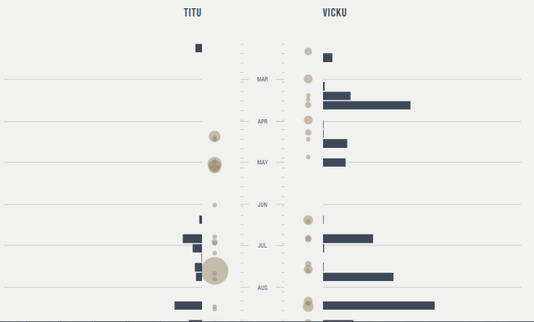

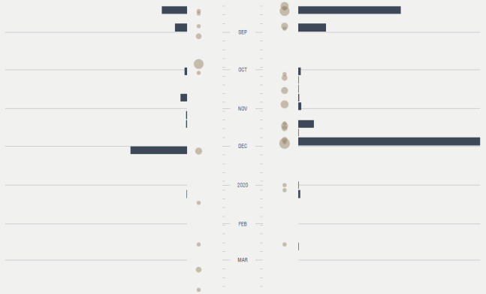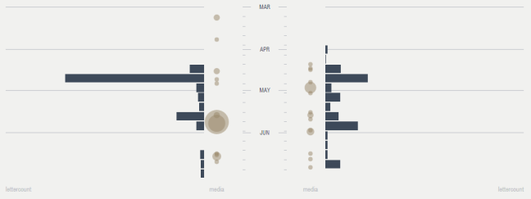

Tops: Most Active Day April 25th, 2020

Average:

Average word per message = 2.54

Average letter per message = 13.53

Average message per day = 1

Average letter per day= 15

File and location: Total files and location sent, files= 261

Activity by time of day: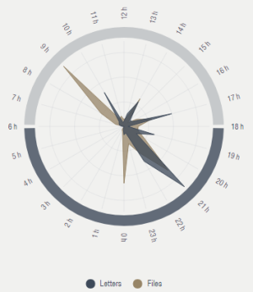

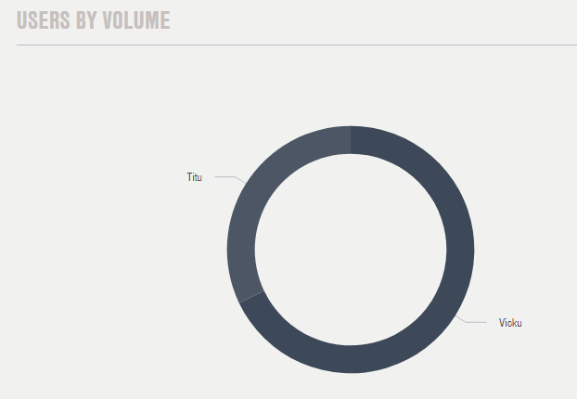

**WhatsApp Group Chat Analysis:**

